Lesson Study
TEAM NOTEBOOK
February 2021
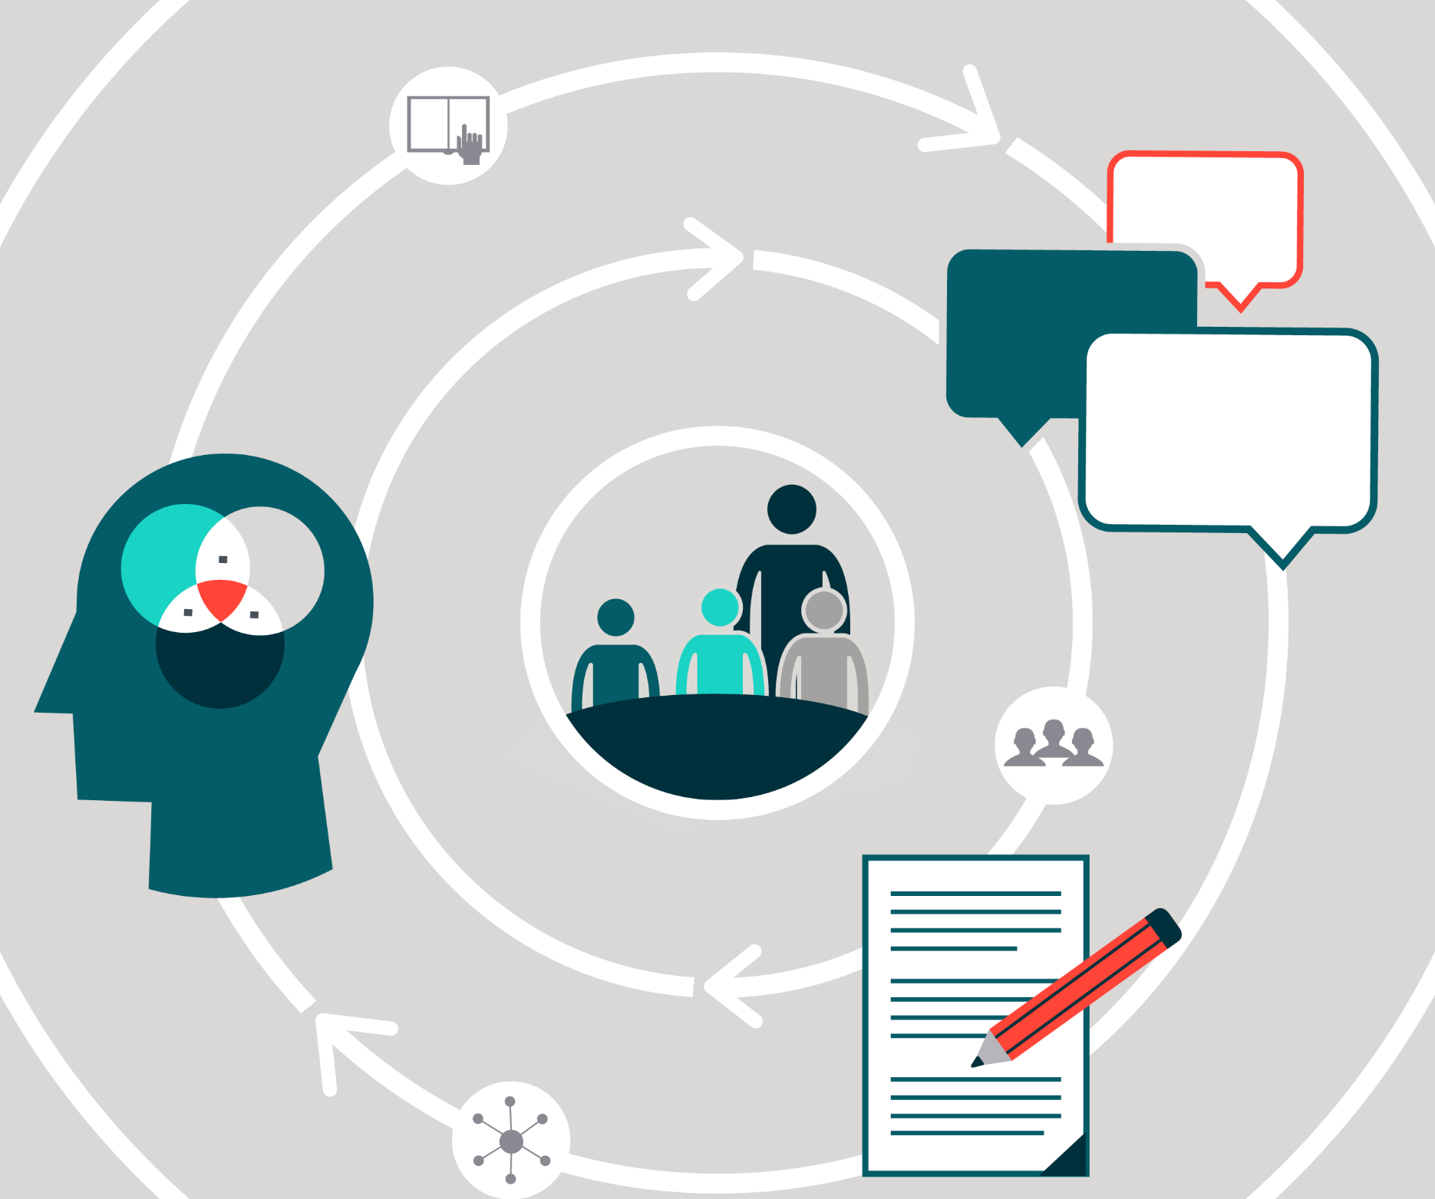

Lesson Study Team Notebook

Team members:

Dates of cycle:

Title of lesson:

Define and assign roles for each meeting
Our team’s roles:

Role | What Will This Person Do During Meetings? | Will We Rotate This Role?

Create and communicate a timeline
Our team’s timeline:

Step | Est. Time | Date and Time | Location
Study and Plan
- Develop Collaboration Norms* | 30 min*
- Establish a Research Theme* | 1 hour*
- Identify and Study the Topic | 2 hours
- Plan the Lesson | 3-6 hours
Teach, Observe, and Debrief
- Teach and Observe the Lesson | 1 hour, additional prep for teacher
- Debrief and Discuss Observation Data | 1-2 hours
Revise and Reteach
- Revise the Lesson | 3 hours
- Reteach, Observe,  and Debrief** | 2-4 hours, additional prep for teacher
Reflect and Report
- Reflect and Report | 2 hours
- Share and Disseminate Knowledge | 1 hour
* This step may not need to be repeated after the first cycle.
** This step may take place in two different locations.

Develop collaboration norms
Our team’s collaboration norms:

Establish a research theme
Our team’s research theme:

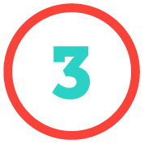

Identify and study the topic
In what way could each of the following data sources inform your team’s selection of
a topic for lesson study?

Student assessment or observational data
Research on student learning challenges and common misconceptions
Instructor learning needs
Curriculum gaps

Respond to the following questions to help make your decision:

What topics are important and persistently difficult for students to learn
and for us to teach?
How does our text treat this topic?
What does the research say about the topic?
Which lesson addresses a concept that is critical to the topic?

Team decision on topic:
___________________________________________________________________________

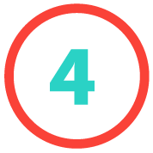
Plan the lesson

Background, Research, and Rationale

Why did you choose this topic?
What did you choose the tasks and activities in the lesson?

Student Learning Outcomes for the Lesson

What do we want students to understand and be able to do by the end
of the lesson?

Student Learning Outcomes for the Lesson (continued)

Time | Learning Tasks and Activities, Anticipated Student Responses, Key Questions | Instructor Support | Assessment
 | Introduction
 | Student Task
 | Anticipated Student Responses
 | Comparing and Discussing
 | Summing Up

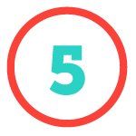
Teach and observe the lesson
Our team’s checklist:

Item | Description | Check when done

Debrief and discuss observation data

Role for debrief | Person Responsible
Moderator
Commentator
Recorder

Debrief 1 summary
Our team’s summary:

Team Member | Success | Challenge | Question

Revise the Lesson

Evidence of students meeting learning outcomes
Evidence of student not meeting learning outcomes
Unanticipated student responses

Student Learning Outcomes for Lesson Plan 2
Time | Learning Tasks and Activities, Anticipated Student Responses, Key Questions | Instructor Support | Assessment
 | Introduction
 | Student Task
 | Anticipated Student Responses
 | Comparing and Discussing
 | Summing Up

Reteach, observe, and debrief

Our team’s checklist:

Item | Description | Check when done

Debrief 2 summary
Our team’s summary:

Team Member | How were the observations about student understanding different from the first lesson? What may have been the causes for these differences? | Did the changes to the lesson bring about the desired changes in student learning? | Keeping the goals in mind, did the changes result in a more effective lesson?

Reflect and Report

Develop and Sustain A Collaborative Team
How well did you and your colleagues collaborate as a lesson study team?
If possible, identify specific factors that contributed to your team’s success
(e.g., discussion items, collaboration norms, or new approaches to any aspect
of lesson study).

Describe how you overcame specific challenges to your cycle.
Describe any new insights or questions about student learning that resulted from your work with this research theme.

Study Research and Apply Evidence-Based Practices
How did your team study the research and apply evidence-based practices? Which research did your team use?

How did the team address and/or strengthen “learning progressions” for
this topic (i.e., the sequence of tasks, activities, and lessons that build on
prior knowledge)?
What other research topics would you have liked to explore more deeply during this cycle (and may wish to explore in future cycles)?

Generate and Share Professional Knowledge
Describe any new insights or questions about student learning that resulted from the work on this research theme.
What did the team learn that can be generalized and applied more broadly in team members’ teaching practice? Describe when it might be most useful to use this learning (e.g., which lessons or topics being taught).
How will you share this learning with others? If possible, propose a specific method for disseminating these learnings.

Share and disseminate knowledge

Audience: Who would be interested in our work? | Purpose: What would we want them to understand? What would we want them to do with this information? | Method: What are effective ways of communicating? | Timeline: When can we do this?

